Message Queues / Streams
# Source: AI Source: Provided by: [Data Path: Persons Table -> ID Column: 1, Name_En Column: Motasem Essam] -> From: [ChatGPT] on [1/23/2026]
Message Queues / Streams is an architectural pattern where components communicate asynchronously by sending messages through a queue or stream, instead of calling each other directly.
👉 Think of it like a post office system:
You send a message → it waits in a queue → someone processes it later

🔑 Key Idea
# Source: AI Source: Provided by: [Data Path: Persons Table -> ID Column: 1, Name_En Column: Motasem Essam] -> From: [ChatGPT] on [1/23/2026]
- Decouple components using messages
- Enable asynchronous communication
- Improve scalability and reliability

🧱 Structure
# Source: AI Source: Provided by: [Data Path: Persons Table -> ID Column: 1, Name_En Column: Motasem Essam] -> From: [ChatGPT] on [1/23/2026]
Producer → Message Queue / Stream → Consumer(s)
- Producer → Sends messages
- Queue / Stream → Stores and delivers messages
- Consumer → Processes messages

🧩 Example – Order Processing System
# Source: AI Source: Provided by: [Data Path: Persons Table -> ID Column: 1, Name_En Column: Motasem Essam] -> From: [ChatGPT] on [1/23/2026]
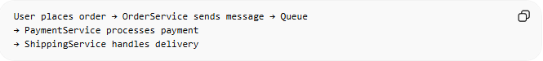
User places order → OrderService sends message → Queue
→ PaymentService processes payment
→ ShippingService handles delivery
👉 Multiple services can process messages independently

💻 Example Code (Conceptual)
# Source: AI Source: Provided by: [Data Path: Persons Table -> ID Column: 1, Name_En Column: Motasem Essam] -> From: [ChatGPT] on [1/23/2026]
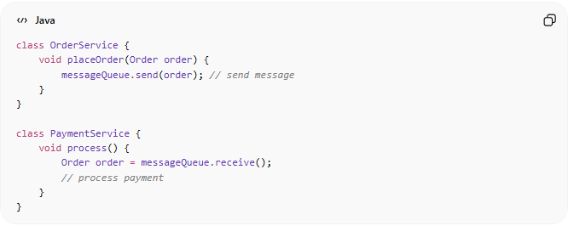
class OrderService {
void placeOrder(Order order) {
messageQueue.send(order); // send message
}
}

class PaymentService {
void process() {
Order order = messageQueue.receive();
// process payment
}
}

❌ Bad Example (Synchronous Communication)
# Source: AI Source: Provided by: [Data Path: Persons Table -> ID Column: 1, Name_En Column: Motasem Essam] -> From: [ChatGPT] on [1/23/2026]
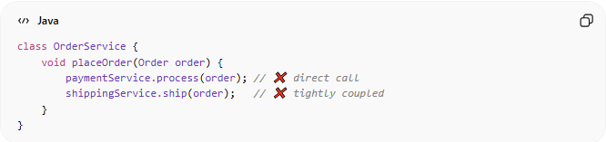
class OrderService {
void placeOrder(Order order) {
paymentService.process(order); // ❌ direct call
shippingService.ship(order); // ❌ tightly coupled
}
}
👉 Problems:
- Tight coupling
- If one service fails → whole process fails
- Hard to scale

✅ Good Example (Using Queue / Stream)
# Source: AI Source: Provided by: [Data Path: Persons Table -> ID Column: 1, Name_En Column: Motasem Essam] -> From: [ChatGPT] on [1/23/2026]
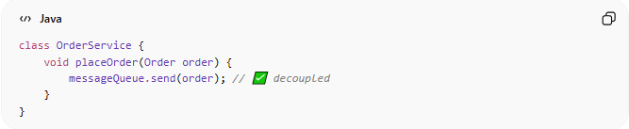
class OrderService {
void placeOrder(Order order) {
messageQueue.send(order); // ✅ decoupled
}
}
👉 Benefits:
- Services work independently
- System becomes resilient and scalable

🔄 Queue vs Stream (Quick Difference)
# Source: AI Source: Provided by: [Data Path: Persons Table -> ID Column: 1, Name_En Column: Motasem Essam] -> From: [ChatGPT] on [1/23/2026]
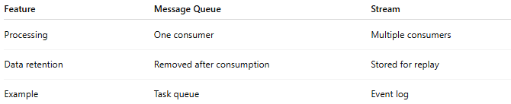
Feature | Message Queue | Stream
Processing | One consumer | Multiple consumers
Data retention | Removed after consumption | Stored for replay
Example | Task queue | Event log

🔄 Use Cases
# Source: AI Source: Provided by: [Data Path: Persons Table -> ID Column: 1, Name_En Column: Motasem Essam] -> From: [ChatGPT] on [1/23/2026]
- Microservices communication
- Event-driven systems
- Background jobs (emails, notifications)
- Real-time data pipelines

⚠️ Common Mistakes
# Source: AI Source: Provided by: [Data Path: Persons Table -> ID Column: 1, Name_En Column: Motasem Essam] -> From: [ChatGPT] on [1/23/2026]
- Not handling message failures/retries ❌
- Ignoring message ordering ❌
- Overloading a single queue ❌

💡 Key Idea
# Source: AI Source: Provided by: [Data Path: Persons Table -> ID Column: 1, Name_En Column: Motasem Essam] -> From: [ChatGPT] on [1/23/2026]
Message Queues / Streams enable loose coupling and asynchronous processing, making systems more scalable and resilient

🧾 Summary
# Source: AI Source: Provided by: [Data Path: Persons Table -> ID Column: 1, Name_En Column: Motasem Essam] -> From: [ChatGPT] on [1/23/2026]
- Producer → Queue/Stream → Consumer
- Enables async communication
- Improves scalability, reliability, and decoupling

